Objectives

• Explain React components

• Identify the differences between components and JavaScript functions

• Identify the types of components

• Explain class component

• Explain function component

• Define component constructor

• Define render() function

In this hands-on lab, you will learn how to:

• Create a function component

• Apply style to components

• Render a component

Prerequisites

The following is required to complete this hands-on lab:

• Node.js

• NPM

• Visual Studio Code

Notes

Estimated time to complete this lab: 30 minutes.

Create a react app for Student Management Portal named scorecalculatorapp and create a function component named “CalculateScore” which will accept Name, School, Total and goal in order to calculate the average score of a student and display the same.

1. Create a React project named “scorecalculatorapp” type the following command in terminal of Visual studio:



2. Create a new folder under Src folder with the name “Components”. Add a new file named “CalculateScore.js”

3. Type the following code in CalculateScore.js

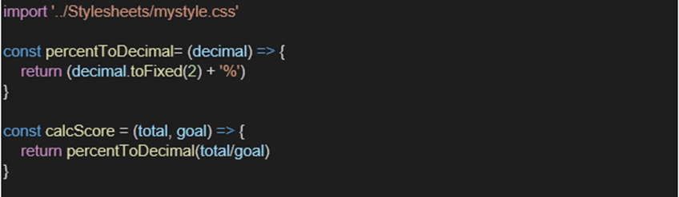

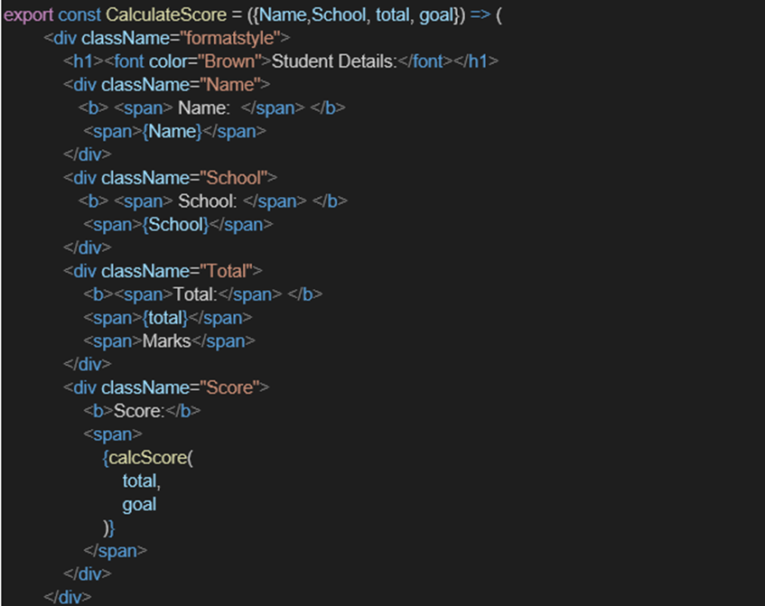

4. Create a Folder named Stylesheets and add a file named “mystyle.css” in order to add some styles to the components:

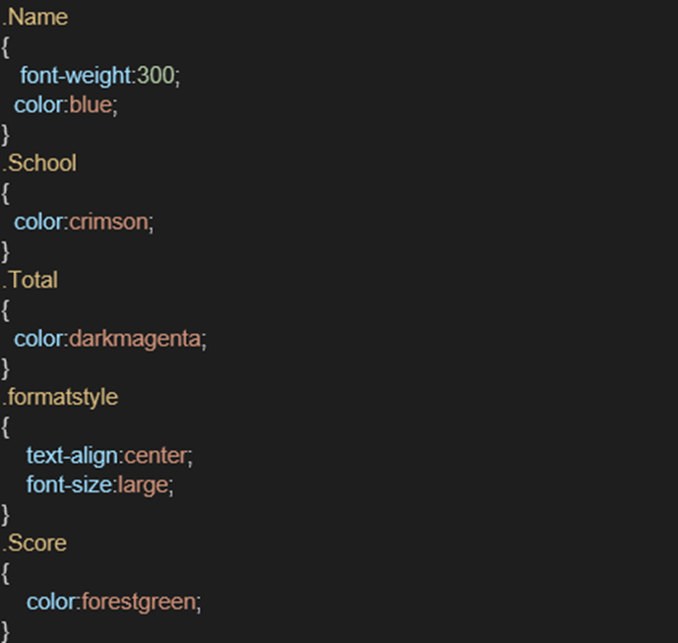

5. Edit the App.js to invoke the CalculateScore functional component as follows:

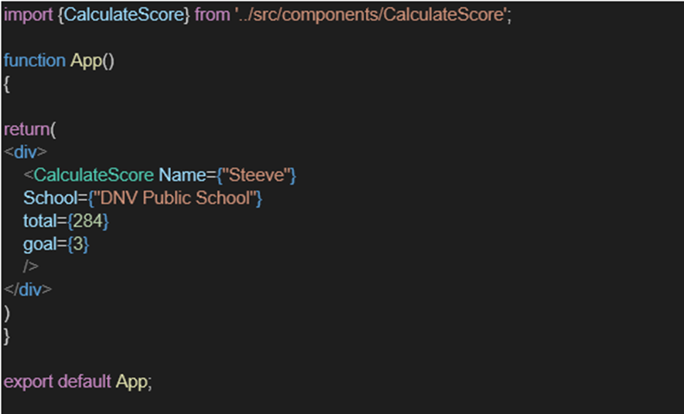

6. In command Prompt, navigate into scorecalculatorapp and execute the code by typing the following command:



7. Open browser and type “localhost:3000” in the address bar:

